Counselling Management System
1. Introduction
This report details the design of a Counselling Management System. The primary tool used for this project is a Logical Data Flow Diagram (DFD). This type of diagram focuses on the business operations of the system, showing how information flows between its processes, the users, and its data storage.¹ The logical approach is used to ensure a clear understanding of what the system must do before any technical decisions are made.
2. Requirements Gathering & Case Study
The system's requirements were gathered by studying the needs of a university Counselling office. This analysis revealed the three primary users, or External Entities, who interact with the system.
- Students/Clients: Need to log in, manage their personal details, and request Counselling appointments.
- Counsellors: Need to log in, view their schedules, write confidential session notes, and record important details.
- Secretary: Need to log in to schedule appointments for both students and counselors and create administrative reports.
The case study for this project is the Counselling Management System itself. The system is designed to streamline operations by handling tasks automatically, keeping records safe, and improving communication among staff.
3. Data Flow Diagram & Use Case Analysis
The Data Flow Diagram for this system shows its internal workings. It breaks the system into key processes and details how information moves between them and the data stores. A use case was created for a core function, illustrating the flow of a typical user interaction.

Use Case: Manage Counselling Appointment
- Primary Actor: Student/Client
- Supporting Actors: Counsellor, Secretary
- Goal: To allow students to efficiently request and attend Counselling sessions.

- Precondition
  - The student is registered in the system and has valid login credentials
- Main Flow:
  - The student logs into the system.
  - The student views available Counselling slots.
  - The student selects the preferred date and time.
  - The system checks the counsellor's schedule.
  - The secretary or the system confirms the appointment.
  - The student receives confirmation.
- Alternative Flow:
  - If the chosen slot is unavailable, the system suggests another slot.
  - If login fails, the student is prompted to retry with the correct details.
- Postcondition:
  - The appointment details are stored in the Appointment Database.
  - The counselor’s schedule is updated accordingly.

4. Data Flow Diagram Components
Level 0 (Context Diagram)
The system is first represented as a single process, the "Counselling System." This high-level diagram connects to the three external entities (Student/Client, Counsellor, Secretary) with labeled arrows showing the main data that flows in and out. This makes it easier to see the overall picture before breaking it down into more detail in the Level 1 Data Flow Diagram.
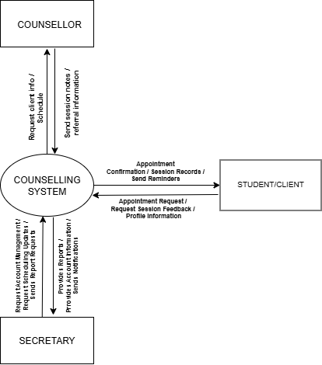

Counselling Data Flow Diagram (Level 0)

Level 1 (Detailed Diagram)
The Level 1 Data Flow Diagram shows what happens inside the system step-by-step. The system has five important processes and five data stores.
Main Processes
- 1.0 User Authentication – Verifies user login requests against the database.
- 2.0 Manage Client Records – Handles all personal information for students and staff.
- 3.0 Manage Appointments – Manages the booking, rescheduling, and canceling of meetings.
- 4.0 Counselling Session Management – Allows counsellors to record session notes.
- 5.0 Generate Reports – Produces reports for the secretary.
Data Stores
- D1: User Credentials DB – Stores usernames and passwords.
- D2: Client DB – Stores student profile details.
- D3: Appointments DB – Saves all appointment information.
- D4: Session Notes DB – A highly secure, private storage area for counseling notes.
- D5: Reports DB – Stores all generated reports.
The arrows on the diagram show how data flows between the users, the processes, and the data stores. Every action typically has two parts: a request and a response. For example, a student's Login Request is sent to the system, which checks the User Credentials DB and then sends back a Login Success or Failure message.

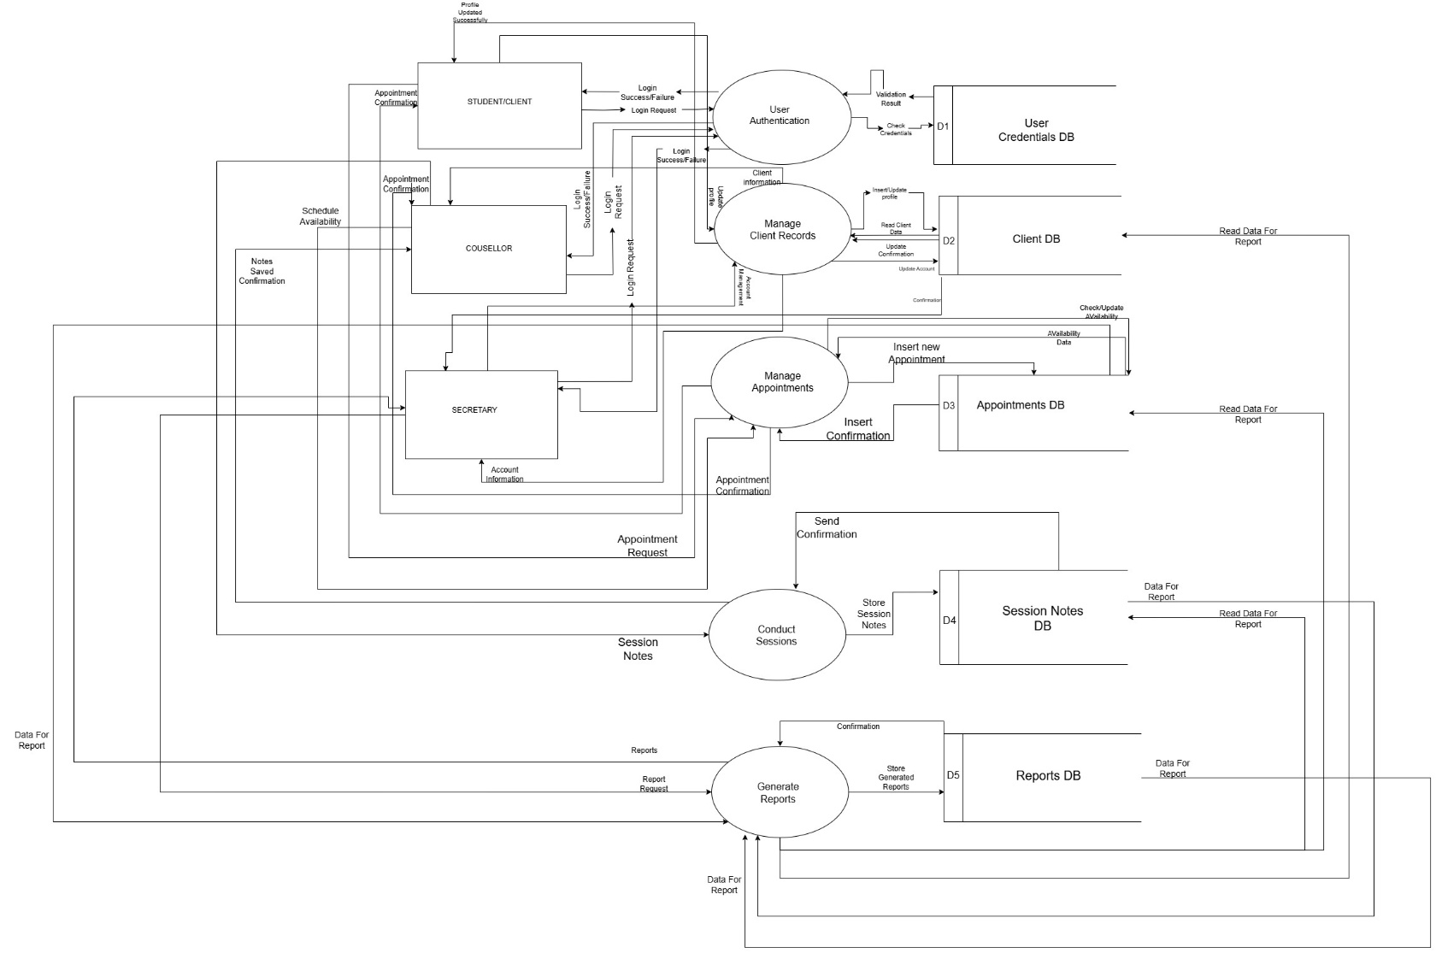
Level 1 Data Flow Diagram

4. Explanation of Connections
Process 1: Authentication
- External entities (Student/Client, Counselor, Secretary) send login requests.
- The system checks credentials against D1: User Accounts.
- If correct, access is granted, and the user can move on to other processes.

Process 2: Manage Client Records
- Counselors and secretaries can add or update client records.
- Data is stored in D2: Client Records.
- Updated details can later be used in sessions or for reports.
Process 3: Manage Appointments
- Students request or view appointments.
- Secretaries confirm and store details in D3: Appointments.
- Appointment info flows to counselors so they can prepare for sessions.
Process 4: Conduct Sessions
- Counselors record notes and session details.
- Notes are securely stored in D4: Session Notes (only counselors can access this).
- If a referral is needed, the system alerts the secretary immediately.
Process 5: Generate Reports
- The secretary retrieves data from Appointments (D3), Client Records (D2), and Records (D5).
- Reports such as Appointment Statistics and Audit Logs are generated.
- This help improve accountability and efficiency in the office.
Overall Flow
Login → Manage Records/Appointments → Conduct Sessions → Generate Reports.
All processes are linked by the data stores (D1–D5).
NB: External entities (students, counselors, secretary) interact through the processes, never directly with the data stores.

6. Conclusion
The Data Flow Diagram of the Counselling Management System provides a clear, business-oriented view of how data flows. The design effectively solves common problems faced in Counselling centers, such as disorganized scheduling and a lack of proper record-keeping. By handling tasks automatically, keeping information secure, and providing clear reports, the system improves efficiency, builds accountability, and enhances the counselling experience for both students and staff.

